- Purpose
  - The purpose of this document is to describe the procedure for assembling the TDS Board for all Genesys machines with SoliChem.
- Scope
  - This SOP applies to all equipment assembly team members. The process applies to all the Genesys machines with the SoliChem option
- Responsibilities
  - The operations manager/supervisor is responsible for enforcing this SOP.
- Materials
  - The proper materials needed for this process are listed on the machine work order.
- Definitions

- Procedure
  - Take a TDS board (E28784). Remove the jumper shown.

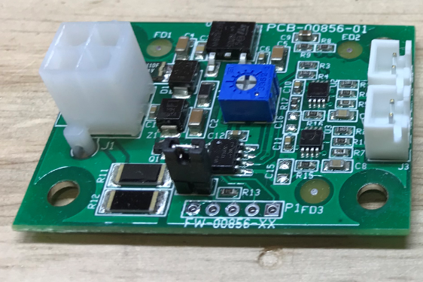

  - Take a TDS Shield Bracket (E28778). Place a spacer (E29373) over each of the 4 studs in the
bracket. Place the TDS Board over the studs and secure it with 4 nuts (E29381). Note the orientation of the board to the hole in the box.
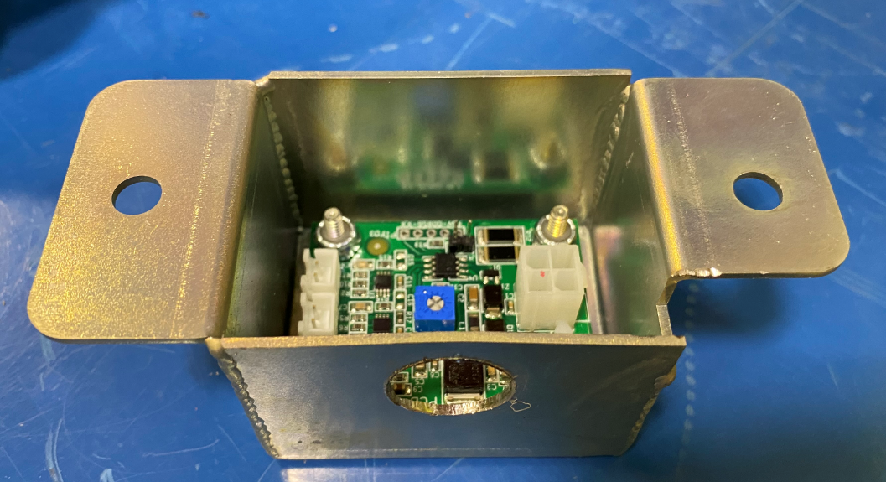
- References (optional section as needed)

- Training Guide

Functional Training Groups Requiring Training
Equipment Assembly Group

- SOP Change Control

Date of Change | Reason for Change
TBD | This is the first version of the S.O.P. hence there are no revisions to this document.
8/13/2021 | Added QC Checks and added probe installation
10/26/2021 | Remove probe installation
11/6/2023 | Updated current process

Approvals

Submitter/Author Approval:__________________________________ Date:______________________

Management Approval:______________________________________ Date:______________________

QAU Approval:_____________________________________________ Date:______________________

